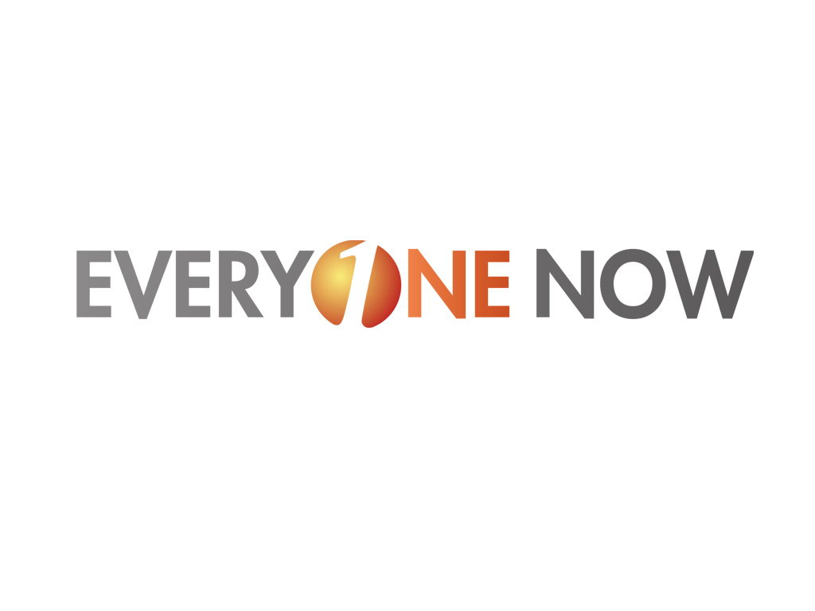
Commission Pay Plan

Everyone Now Independent Sales Affiliate Definitions

Everyone Now offers two ways to become an Independent Sales Affiliate of Everyone Now Products and Services:

Referral Sales Affiliate (RSA)
A Referral Sales Affiliate is an Independent Contractor who chooses not to enroll in the optional Everyone Now Independent Sales Affiliate Program. Instead, they pay a one-time, refundable application deposit of Sixty-Nine Dollars ($69.00)*, with an annual renewal fee of Sixty-Nine Dollars ($69.00)*.
- Unlike Independent Sales Affiliates, Referral Affiliates do not receive access to the Company's back office (Freedom Now Business Management Center) and cannot sign up for their own Personal Website. Referral Affiliates can qualify for all of the same Customer Acquisition Bonuses (CAB) and commissions available to ISAs, however, a Referral Affiliate is not eligible to participate in any company-wide shared funds nor will the direct enroller and/or leadership teams receive Team Leadership Bonuses on the Referral Affiliate’s personal customer sales. A Referral Affiliate may cancel their status with the Company, in writing, at any time and they will receive a full refund (less any commissions earned) of their deposit.
A Referral Affiliate can upgrade to Independent Sales Affiliate at any time for an additional fee of Two Hundred Thirty Dollars ($230.00)* by contacting Everyone Now Affiliate Support at 251-706-1443. Upgrading to ISA provides the former Referral Affiliate full access to the Freedom Now Business Management Center and allows them to sign up for their own personalized Website and to begin earning all commissions available to ISAs.

* The initial cost of the optional Everyone Now Independent Sales Affiliate Program may differ in some states.

Independent Sales Affiliate (ISA)

An Independent Sales Affiliate is an Independent Contractor who chooses to enroll in the Everyone Now Independent Sales Affiliate Program. Independent Sales Affiliates will receive product, service and company training and back office support complete with team and commission reports in the form of a personalized “Affiliate Management Center”. The Independent Sales Affiliate can also sign up for their own personalized Website.

The initial cost of the Program is Two Hundred Twenty Nine Dollars ($299.00)* with an annual renewal fee of Ninety-Nine Dollars ($99.00)*.

* Any Independent Sales Affiliate who enrolls in the Everyone Now Services Independent Sales Affiliate Program may cancel in writing within 3 days (72 hours) of the date the Application and Agreement have been electronically received by Everyone Now and receive a full refund. The initial cost of the optional Everyone Now Independent Sales Affiliate Program may differ in some states.

Please note: Everyone Now, LLC is an Affiliate Marketing Company focused on Customer Acquisition and financially rewards it’s Affiliates for Customer Acquisition. There is no money earned or paid without the sale of services or products to customers, of which seventy (70%) must be from outside the Referral Sales Affiliate or Independent Sales Affiliate’s personal use and or consumption with no exceptions.

The Everyone Now Online Rewards Mall:

Included in your personal Everyone Now website is a highly sophisticated online shopping Rewards Mall that contains over Eleven Hundred (1,100) affiliated merchants/stores who participate in the Everyone Now Rewards Mall. This program is designed to create the largest loyalty program in the country for consumers. These consumers can be Independent Affiliates or Customers of Independent Affiliates. Membership to the Everyone Now Rewards Mall is free of charge, whether you are an Independent Sales Affiliate or a customer of an Independent Sales Affiliate. The Mall program is setup in such a way that the Affiliated Merchants agree to pay a commission from sales that are generated through the Rewards Mall from the Affiliate Marketers from Everyone Now. Each Independent Affiliate who has a personalized Everyone Now Affiliate Website will have an Online Rewards Mall included at no additional cost. The Independent Affiliate and/or the Affiliate’s Customers will not only earn cash back rewards, but Everyone now will also pay the Independent Affiliate monthly commissions based on the products sold from their Rewards Mall; these commissions will be paid in conjunction with “Monthly Residual Income” (MRI). Everyone Now will also contribute a percentage of commissions to the CAB Shared Fund from the Rewards Mall.

Cash Back Rewards: How They Work

Example: 1-800 Flowers.com decides to pay a Twenty Percent (20%) commission for sales generated from the Everyone Now Rewards Mall. The purchasing consumer/member earns Fifty Percent (50%) of the commission – in this case Ten Percent (10%) and the commission to the purchasing consumer/member is paid as Reward Points (each Reward Point equals One Dollar [$1.00]) approximately Forty-Five Days (45) after their purchase has been completed. Once the purchasing consumer/member earns Fifty (50) Reward Points, the member will have the option to receive a MUSTeam Discover Card with the Fifty Dollar ($50.00) value credit loaded on the card. Thereafter, the purchasing consumer/member can transfer those Reward credits to his card as they are earned. The money on the MUSTeam Discover card can be used to purchase products in the Everyone Now Rewards Mall, which earns additional reward/money credit, or the card can be used at any Discover Merchant in the country. If the Merchant is a participant in the MUST Discover card in-store program, the purchasing consumer/member will earn reward points on those purchases also. The cardholder may also purchase additional cards that can be used for children or family. Money can be loaded on their MUSTeam Discover cards through thousands of loading stations around the country and funds may also be loaded electronically through the mobile application.

Online Reward Mall Affiliate Commissions

In the example used above, 1-800 Flowers.com pays a total of Twenty Percent (20%) commission and Ten Percent (10%) was paid to the Independent Sales Affiliate, or customer as Reward Points. The remaining Ten Percent (10%) commission goes to the Everyone Now Reward Mall service provider, from that Ten Percent (10%) Everyone Now receives Fifty Percent (50%) from the Reward Mall service provider and of the Fifty Percent (50%) that Everyone Now receives, Everyone Now will pay a total of Seventy Percent (70%) to the Independent Affiliates in the following two manners: 1) Everyone Now will pay the Independent Affiliate from where the link originated (i.e. their Personal Everyone Now Rewards Mall) a total of Sixty Percent (60%) of the Seventy Percent (70%) that Everyone Now receives; and, 2) Everyone Now will also put a total of Ten Percent (10%) of the Seventy Percent (70%) into the CAB Shared Fund.

Weekly Commissions and Bonuses

Personal Accelerator

You can earn a Personal Accelerator payment of Fifty Dollars ($50.00) when you reach the qualification level of 5 personal customer points*, ** within your first 30 days of enrollment.

*An active personal Everyone Now Website subscription counts as 1 Customer Point.
**Must include a minimum of 3 active points from customer acquisition outside of the Affiliate’s home. Self-Consumption of the full 5-point requirement does not qualify.

Personal Accelerator Bonus

You can earn a Personal Accelerator Bonus payment of One Hundred Dollars ($100.00) when you reach the qualification level of 5 personal customer points*, **within your first 7 days of enrollment***.

*An active personal Everyone Now Website subscription counts as 1 Customer Point.
**Must include a minimum of 3 active points from customer acquisition. Self-Consumption of the full 5-point requirement does not qualify.
***If you do not achieve the qualification level of 5 Customer Points* within your first 7 days but do reach the qualification level within your first 30 days, you will earn the Personal Fast Start payment of Fifty Dollars ($50.00).

New Affiliate Team Member Bonus

You earn Fifty Dollars ($50.00) each time a New Independent Sales Affiliate who you directly, or personally sponsored achieves a Personal Accelerator or a Personal Accelerator Bonus. You must be a qualified ISA in order to receive the New Affiliate Team Member Bonus and the qualification period is based upon a rolling Five Week (5) period.

Your Everyone Now Founding Team Building Matching Bonus

As you begin to build your Everyone Now team, the first Ten (10) Independent Sales Affiliates (ISAs) that are personally sponsored by you will be called your “Everyone Now Founding Team” and will permanently maintain that designation throughout the system for their duration in Everyone Now. Everyone Now will pay you, as their sponsor, a Ten Percent (10%) Founding Team Building Matching Bonus on the first Twenty-Five Thousand Dollars ($25,000.00) of total monthly residual income paid to each member of your Founding Team. Both you, and the Independent Sales Affiliates on your Founding Team must maintain a minimum status of Qualified Independent Sales Affiliate*, in order for the Founding Team Building Matching Bonus to be applicable. The Founding Team Building Matching Bonus is calculated on a monthly basis, beginning the first day of the month following the month in which a personally sponsored Independent Affiliate is considered Qualified*. The Founding Team Building Matching Bonus encompasses only your first Ten (10) personally enrolled ISAs, is paid on the total of monthly residual income and will be paid in conjunction with Monthly Residual Checks**.

*Defined on pages 8 of this document
** Commission payments will only be issued in amounts exceeding Twenty-Five Dollars ($25.00)

Team Leadership Bonuses

As you continue to build your Everyone Now team and advance through the Everyone Now Team Leadership Positions, you can qualify to earn additional Team Leadership Bonuses. Accelerator Bonuses (AB) and Team Leadership Bonuses (TLB) are triggered throughout the week when an ISA obtains his or her 5th active personal customer point. Each Friday at 11:59pm (ET) the week is considered “closed” for all bonuses and commissions and all bonuses and commissions are calculated and assigned at that time and all earned bonuses will be paid in the following week’s commissions.
As you continue to progress through the Everyone Now Leadership Positions, you can earn Team Leadership Bonuses to UNLIMITED levels by meeting the promotional and/or personal customer point requirements* and reaching any of the four (SAM, SASM, SAD and SAVP) Team Leadership positions. At each Team Leadership position, you can begin to build a new Everyone Now team and you can also become eligible to earn additional Team Leadership Bonuses on your new Everyone Now Team.

Team Leadership Bonuses are paid when a new ISA enters your leadership team on any leadership level (SAM, SASM, SAD and SAVP) level; obtains five active Customer Points and generates a Personal Accelerator Bonus. ISAs who entered your team before you obtained a leadership position are in the leadership team of the first person above your leadership level and in the leadership position before you.

You must have 10-50 personal Customer Points and team members or 50-1000 personal Customer Points*, each in an active status based on your leadership position on the qualification date (the last day of the month) and an active Everyone Now personal website in order to receive Team Leadership Bonuses throughout the following month.

*Defined on pages 8 and 9 of this document

Everyone Now Team Leadership Bonus (TLB) Payment Structure:

Sales Affiliate Manager (SAM): Forty Dollars ($40.00)
______________________________________________________________________________________

Sales Affiliate Senior Manager (SASM): Thirty Dollars (30.00)
______________________________________________________________________________________

Sales Affiliate Director (SAD): Twenty Dollars ($20.00)
_______________________________________________________________________________________

Sales Affiliate Vice President (SAVP): Ten Dollars ($10.00)
_______________________________________________________________________________________

Monthly Commissions:

Monthly Residual Commissions

Everyone Now also pays Affiliate monthly commissions; these commissions are called “Monthly Residual Income” (MRI). You build MRI by personally marketing and selling Everyone Now products and services, as well as from the sales of Everyone Now products and services to the customers acquired by the ISAs in your team, up to five levels in depth, with infinite width. Everyone Now pays MRI on Contracted services (Dish Network, Front Point Security and Wireless Services, for example) for a total of Twelve (12) Months from the contract date; Everyone Now pays MRI indefinitely on Non-Contracted services (Nutritional, VoIP, Benefits, for example) provided each customer account is paid and in good standing.

MRI is calculated on the 15th of the month immediately following the month the customer payment is received and processed by Everyone Now and is paid at the end of the month. In order to receive MRI on both your personal and Everyone Now team sales you must be a qualified Independent Sales Affiliate and must have the minimum number of personal active Everyone Now Customer Points to be eligible.

MRI is paid on all personal customers*, *** and five additional levels deep with infinite width on each of the five levels. Affiliate commissions are paid on the designated dollar amount or percentage of sale price assigned to each individual Everyone Now product or service, which qualifies for residual payment. Please refer to this document and the corresponding chart in your Freedom Now Business Management Center for the most updated and detailed residual dollar amounts **.
*Personal Everyone Now website subscriptions are not included
** Commission payments will only be issued in amounts exceeding Twenty-Five Dollars ($25.00)
*** Detailed on page 11 of this document

Monthly Residual Bonuses

As you progress through the Everyone Now Leadership Positions, you can earn Monthly Residual Bonuses to UNLIMITED levels by meeting the promotion and customer point requirements* and reaching any of four (SAM, SASM, SAD and SAVP) leadership positions*, ****. Monthly Residual Bonuses are paid to UNLIMITED levels. Affiliate commissions are paid on the designated dollar amount or percentage of sale price assigned to each individual Everyone Now service, which qualifies for residual payment. Please refer to this document and the corresponding chart in the Freedom Now Business Management Center for most updated and detailed Residual Bonus dollar amounts. **, ***.

*Defined on pages 8 and 9 of this document
**Personal Everyone Now website subscriptions are not included
***Commission payments will only be issued in amounts exceeding Twenty-Five Dollars ($25.00)
****Detailed on page 11 of this document

Customer Acquisition Bonuses (CAB)

Everyone Now pays Customer Acquisition Bonuses for many products and services, which are personally sold. Please refer to this document and the corresponding chart in the Freedom Now Business Management Center for detailed, updated and actual CAB dollar amounts. CABs are calculated on the 15th of the month immediately following the month the customer activation takes place and is considered “Active” and is paid in conjunction with the weekly commission check run. In order to receive CABs you must be a Qualified Independent Sales Affiliate and must have the minimum number of personal active Everyone Now Customer Points to be eligible**.

Company-Wide Customer Acquisition Bonus (CAB) Shared Fund

To further reward our Affiliates, Everyone Now offers a Company Wide Customer Acquisition Shared Fund (CAB). Everyone Now will place Ten Percent (10%) of matching individual CAB Bonus payments earned on every qualified service into a fund, called the CAB Shared Fund. (Please refer to this document and the corresponding chart in the Freedom Now Business Management Center to review the services that apply toward the CAB Shared Fund). Each Leadership position participates at a full Twenty-Five Percent (25%) of the total fund amount available. CAB fund revenues are calculated on the 15th of the month immediately following the month the customer activation takes place and is considered “Active” and is paid at the end of the month, in conjunction with MRI commissions. In order to receive CAB fund commissions, you must be a Qualified Independent Sales Affiliate and must meet the qualified leadership level associated with your title* and meet the additional requirements defined below to be eligible. You will be paid only at the highest leadership level obtained for the respective month **.

Customer Acquisition Bonus (CAB) Shared Fund Payment Structure and Qualifications:

Sales Affiliate Manager (SAM) Twenty-Five Percent (25%)

- Have 4 new personal sales/month

Sales Affiliate Senior Manager (SASM) Twenty-Five Percent (25%)

- Have 3 new personal sales/month

Sales Affiliate Director (SAD) Twenty-Five Percent (25%)

- Have 2 new personal sales/month

Sales Affiliate Vice President (SAVP) Twenty-Five Percent (25%)

- Have 1 new personal sales/month

*Defined on pages 8 and 9 of this document
**Commission payments will only be issued in amounts exceeding Twenty-Five Dollars ($25.00)

Company-Wide Wellness (CWW) Shared Fund

To further reward our Affiliates, Everyone Now offers a Company Wide Wellness Shared Fund (CWW). Everyone Now will place Five Percent (5%) of company-wide revenues earned on all qualified Nutritional, Beauty, Skin Care and Fitness supplements product sales into a fund, called the CWW Shared Fund. (Please refer to this document and the corresponding chart in the Freedom Now Business Management Center to review the products that apply toward the CWW fund). Each Leadership position participates at a full Twenty-Five Percent (25%) of the total fund amount available. CWW fund revenues are calculated on the 15th of the month immediately following the prior month, in conjunction with MRI commissions. In order to receive CWW fund commissions, you must be a Qualified Independent Sales Affiliate and must meet the qualified leadership level associated with your title* and meet the additional requirements defined below to be eligible. You will be paid only at the highest leadership level obtained for the respective month **.

Company-Wide Wellness (CWW) Shared Fund Payment Structure and Qualifications:

Sales Affiliate Manager (SAM) Twenty-Five Percent (25%)

- Maintain a minimum of $1000/month in personal sales volume

Sales Affiliate Senior Manager (SASM) Twenty-Five Percent (25%)

- Maintain a minimum of $1000/month in personal sales volume

Sales Affiliate Director (SAD) Twenty-Five Percent (25%)

- Maintain a minimum of $1000/month in personal sales volume

Sales Affiliate Vice President (SAVP) Twenty-Five Percent (25%)

- Maintain a minimum of $1000/month in personal sales volume

*Defined on pages 8 and 9 of this document
**Commission payments will only be issued in amounts exceeding Twenty-Five Dollars ($25.00)

The Independent Sales Affiliate Vice President Check Match Program

To further reward our Sales Affiliate Vice Presidents for their team growth and sales, we have created the Sales Affiliate Vice President Check Match Program (VPCM). This program is designed to ensure that you will continue to receive income in the event those Independent Sales Affiliates who match or equal your Sales Affiliate Vice President leadership position. The VPCM allows you to earn a Ten Percent (10%) bonus on the first Twenty-Five Thousand Dollars ($25,000.00) of the total monthly income paid to each Sales Affiliate Vice President in your team who reaches the position of Sales Affiliate Vice President and had your Sales Affiliate Vice President coding or were personally sponsored prior to their promotion. These Independent Sales Affiliate(s) must maintain their individual Sales Affiliate Vice President qualifications, which are specified on pages 8 and 9 of the Everyone Now Commission Pay Plan in order for the VPCM to be applicable. The VPCM is calculated on a monthly basis, beginning the first day of the month following the month in which a personally sponsored Independent Affiliate reaches the rank of Sales Affiliate Vice President. The VPCM encompasses all personally enrolled, or ISAs who had your Sales Affiliate Vice President team coding prior to their promotion in your team and will be paid in conjunction with Monthly Residual Checks.

Everyone Now Title Descriptions and Promotion Requirements

Referral Affiliate (RA)

- Enrolled in the Everyone Now Affiliate Referral Sales Program

Independent Sales Affiliate (ISA)

- Enrolled in the Everyone Now Independent Affiliate Sales Program

Qualified Independent Sales Affiliate (QISA)

- Obtain 5 personal active Customer Points*,**

Sales Affiliate Manager (SAM)

- Be an active, qualified QISA
- Have a total of 10 QISAs; 5 of which must be personally sponsored
- Have 10 active personal Customer Points *

- OR -

- Have 50 active personal Customer Points*

Everyone Now Title Descriptions and Promotion Requirements, con’t.

Sales Affiliate Senior Manager (SASM)

- Be an active, qualified SAM
- Have 10 active, qualified personally-enrolled QISAs that were enrolled after you became a SAM (i.e. in your “SAM code”)
- Have a total of 15 total QISAs in your “SAM Code”
- Have 5 of the QISAs in your “SAM Code” promoted to SAM
- Have 15 active personal Customer Points *

- OR -

- Have 250 active personal Customer Points*

Sales Affiliate Director (SAD)

- Be an active, qualified SASM
- Have 15 active, qualified personally-enrolled QISAs that were enrolled after you became a SASM (i.e. in your “SASM code”)
- Have 10 of the QISAs in your “SASM Code” promoted to SASM
- Have 25 active personal Customer Points *

- OR -

- Have 500 active personal Customer Points*

Sales Affiliate Vice President (SAVP)

- Be an active, qualified SAD
- Have 25 active, qualified personally-enrolled QISAs that were enrolled after you became a SAD (i.e. in your “SAD code”)
- Have 15 of the QISAs in your “SAD Code” promoted to SAD
- Have 50 active personal Customer Points *

- OR -

- Have 1000 active Personal Customer Points*

* Active Personal Everyone Now Website subscription counts as 1 Customer Point.
**Must include a minimum of Seventy Percent (70%) active customer points from customer acquisition outside the Independent Sales Affiliate’s personal use and or consumption.

Qualification Grace Period

To receive Monthly Residual Income (MRI) and Leadership Bonuses (LB) you must meet the requirements* and qualify each month for the leadership position you hold within Everyone Now. If you do not qualify, you will be placed in a 30 day Grace Period. This Grace Period** will apply the following month. During the Grace Period, you will still receive the income for that month as if you had been fully qualified.

You must have the required number of active Everyone Now Customer Points* and or Qualified Independent Sales Affiliates for your Leadership Position* on the qualification date, or the Grace Period** will apply the next month. You are not able to use Grace Periods on subsequent periods; should this occur, you will be considered in expired grace, and will only be paid according to the Leadership Position in which you are fully qualified.

Example: You are an SAD and don’t have enough active Customer Points but do have enough to qualify as a SASM: you will be paid as an SASM.

You are allowed only one consecutive Grace Period and must have the required number of active Customer Points on the next qualification date to again be eligible.

*Defined on pages 8 and 9 of this document
**The monthly qualification date is 11:59 PM (ET) on the last day of the month.

Commission Payments
By default, Everyone Now pays commissions via electronic funds transfer (ACH) to a checking or savings account. Should an Independent Affiliate choose to have a check mailed, Everyone Now utilizes the US Postal (USPS) service and a check-processing fee of $3.00 will apply.

